Creating Repository and placing the files   
  
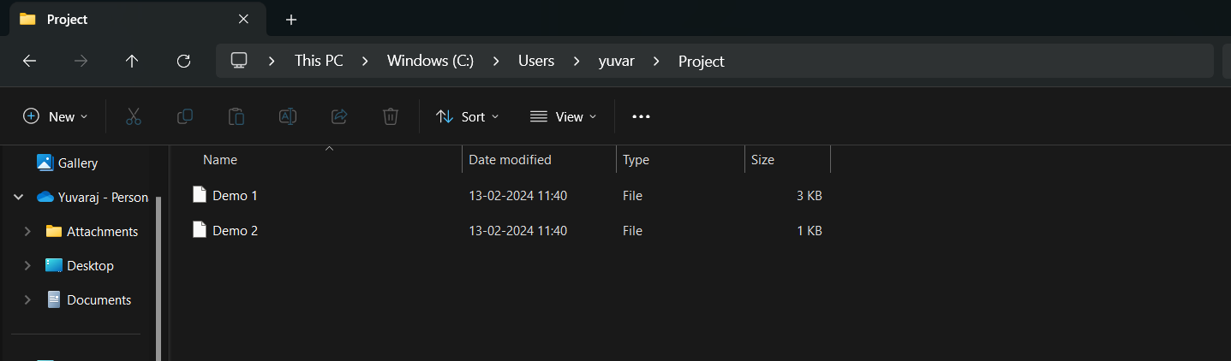

Git Initialization and commit from local:`

yuvar@Vinoth MINGW64 ~

$ cd C:/Users/yuvar/Project

yuvar@Vinoth MINGW64 ~/Project (master)

$ ls -lr

total 0

yuvar@Vinoth MINGW64 ~/Project (master)

$ git init

Reinitialized existing Git repository in C:/Users/yuvar/Project/.git/

yuvar@Vinoth MINGW64 ~/Project (master)

$ git remote add origin https://github.com/Vinoth199/Project.git

yuvar@Vinoth MINGW64 ~/Project (master)

$ git add .

warning: in the working copy of 'Demo 1', LF will be replaced by CRLF the next time Git touches it

warning: in the working copy of 'Demo 2', LF will be replaced by CRLF the next time Git touches it

yuvar@Vinoth MINGW64 ~/Project (master)

$ git commit -m "Initial commit"

[master (root-commit) 3c7bc2e] Initial commit

2 files changed, 66 insertions(+)

create mode 100644 Demo 1

create mode 100644 Demo 2

yuvar@Vinoth MINGW64 ~/Project (master)

$ git push -u origin master

Enumerating objects: 4, done.

Counting objects: 100% (4/4), done.

Delta compression using up to 16 threads

Compressing objects: 100% (4/4), done.

Writing objects: 100% (4/4), 705 bytes | 705.00 KiB/s, done.

Total 4 (delta 0), reused 0 (delta 0), pack-reused 0 (from 0)

To https://github.com/Vinoth199/Project.git

\* [new branch] master -> master

branch 'master' set up to track 'origin/master'.

